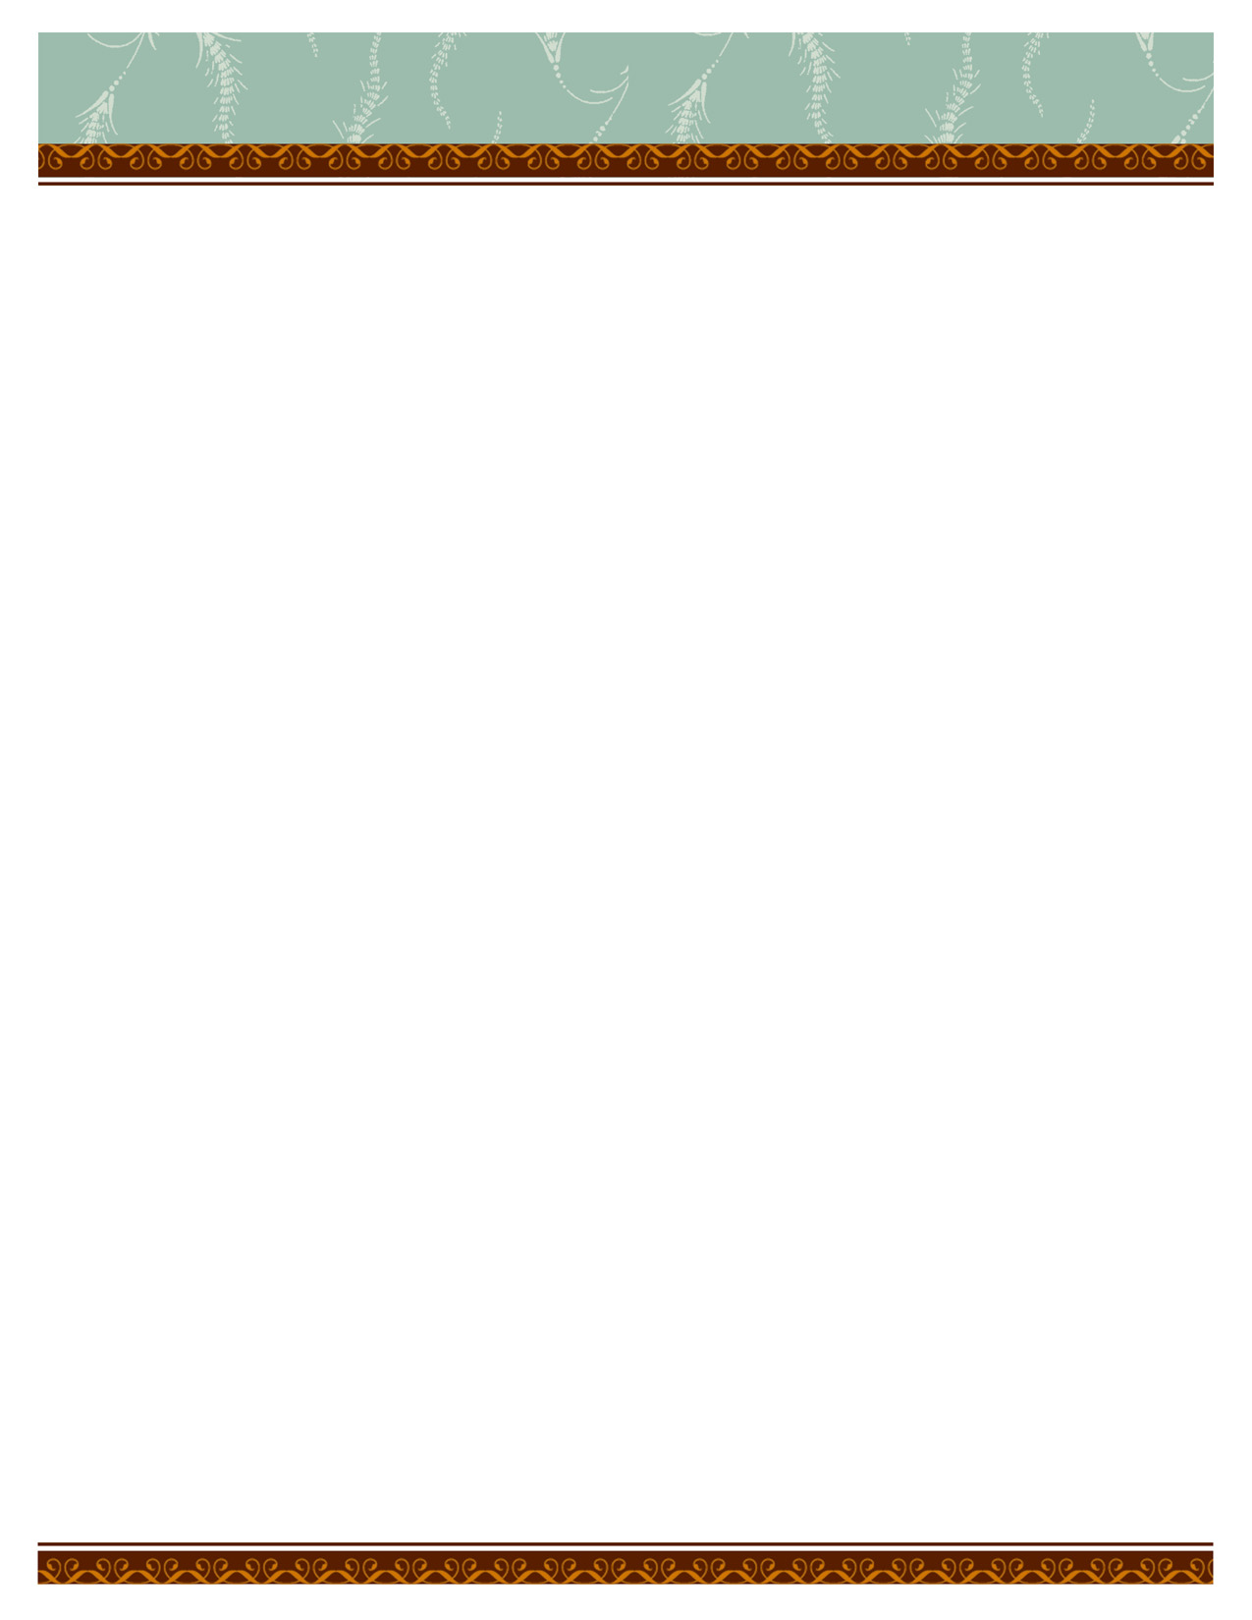

Donna Pence

1468 Harrison Avenue

Salt Lake City, Utah 84105

www.homesteadglass.weebly.com

Letter of Interest for Public Art

To whom it may concern,

I would like to express my interest in being selected as an artist to complete public art projects for Salt Lake City. I am a local Salt Lake City glass artist and Art Educator in the Salt Lake City School District. I believe that I am highly qualified to design, manage, and complete on time and on budget, beautiful original glass mosaic artwork that is specific to site and community context. I have worked with architects, project managers, site inspectors, and builders as a stained glass artist since 1980, as a cabinet designer, and an independent interior remodeling coordinator from 2000 -2008. As an independent contractor, I appreciate the importance of communication, compromise, reliability, and budget constraints. As an artist, I bring to the table my sensitivity to space: to light, color, form, and to historical and cultural aesthetics.

As a Glass Artist:

* I have completed glass installations for numerous private residences since 1980,
* I have participated in the Utah Arts Festival and the Park City Arts Festival as well as arts festivals in other states.
* I have shown my personal work at Michael Berry Gallery, Patrick Moore Gallery, and Gallery 24 in Torrey, Utah.

As a Public Artist:

* I managed the Murray Library Centennial Window project in 2013for The Friends of the Library
* I managed the Magna Fire Station Glass Art installation in 2010 for the United Fire Authority
* I teamed with Paul Heath to manage both the Emigration Fire station glass installation and Redwood Recreation Center glass installation for the Salt Lake County Public Arts program in 2008.
* I assisted with a team of artists on the Bridges over Barriers community mosaic project for the Utah Arts Council.
* I recently teamed with Paul Heath to complete 18 temporary glass mosaic installations over the 7th south Jordan River Bridge overpass for City Planning and The Salt Lake City Arts Council in August of 2013.

Public Artwork as an Art Teacher:

* I coordinated with students from elementary and middle school to create 18 murals for the Salt Lake City Veteran’s Hospital tunnels in 2012
* I coordinated with 6th grade students to create 72 ornaments representing Utah for the National Christmas Tree Celebration in Washington D.C. in 2011
* I am coordinating with 4th grade students to make wall hangings for a community fund raiser in 2014.

phone: 555.555.5555 | fax: 555.555.5555 | 5555 Street Address, City, State 55555 | www.webaddress.com